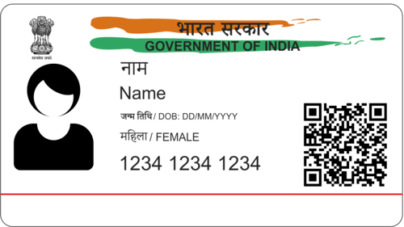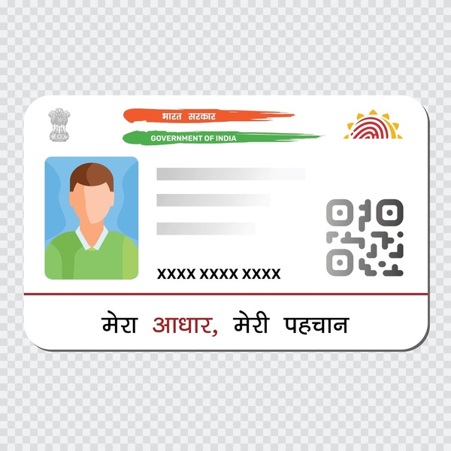

NAME – XXXXXX

D.O.B -XX/XX/20XX

GENDER- FEMALE

8769 9085 8654